**Vision:** The Richmond County School system will provide an equitable education for all students to prepare them for life beyond the classroom.

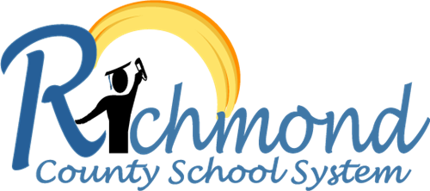

**Mission:** Building a globally competitive school system that educates the whole child through teaching, learning collaboration and innovation.

**Belief Statements:**

1. Every person can learn and has the right to a quality education.

2. Students thrive in a positive climate and culture where they are respected and all ideas are accepted.

3. Effective communication is the key to understanding among people.

4. Excellence in education is a collaborative effort and shared responsibility of the individual, home, school, and community.